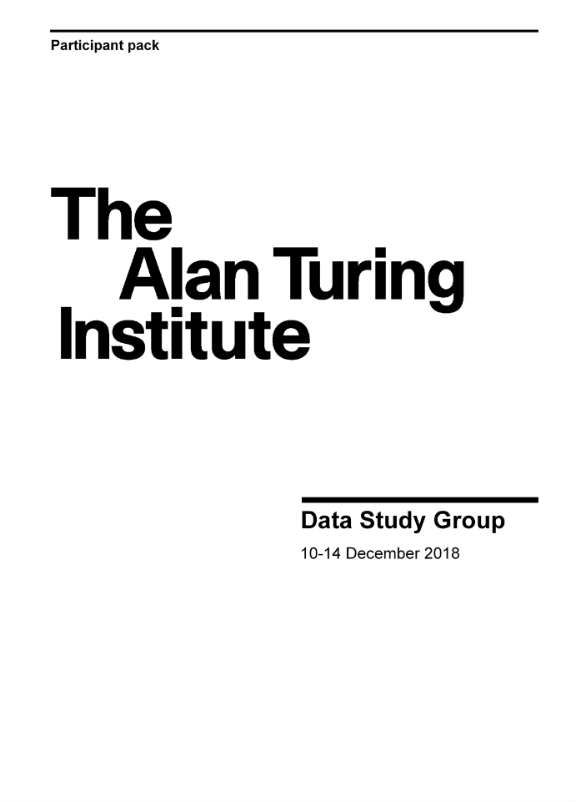

* Submit your PI application to [datastudygroup@turing.ac.uk](mailto:datastudygroup@turing.ac.uk) for the DSG team to review.
* Have a short half hour chat with the DSG team so they can introduce you to the Data Study Group and answer any questions you may have.
* Introductory call with the Challenge Owner (the frequency you speak with the challenge owner varies on a case by case basis, your challenge owner will be aware that communication with you is key to a successful challenge!)
* In collaboration with your challenge owner, agree a challenge title and prepare the short description (this will be used to promote the DSG and attract participants). **– 10 weeks**
* Provide the DSG team your mobile number so you can be given an IT/Safe Haven account which will be used later.
* Complete and submit an ethics form to the Turing Ethics Advisory Group (EAG) **– 9 weeks**
* Amend the EAG form to clarify any points for concern and re-submit until the project is approved.
* Join a call with the DSG Team and your challenge owner so that you can be briefed on the challenge sensitivity assessment. **– 9 weeks**
* Come to the Institute to access the safe haven and take a look at your challenge data. (please book your own travel and keep and receipts to claim expenses). **– 6 weeks**
* Record your sensitivity assessment in the web app. **– 6 weeks**
* Whilst at the institute asses the sensitivity Tier of the challenge data you are refereeing.
* Record your referee assessment in the web app. **– 6 weeks**
* Submit the first draft of your challenge long description to the DSG team to review **– 5 weeks**
* If necessary, update the challenge long description and re-submit.
* Communicate your accommodation and dietary needs for the event to the DSG team.
* Arrange a call or meeting with your challenge facilitator once you have been introduced. **– 1 week** Attend the facilitator training lunch (optional) **– 4 days**
* Book your own travel to attend the event and keep any receipts.
* Set up slack and GitHub so that you can communicate your groups needs to the DSG team.
* Attend the Data Study Group Week (note there is a social on Monday evening which is completely optional, some nights participants will work till as late as 10.30pm you are not obligated to work this late).
* On the Friday DSG week, assess the challenge outputs sensitivity ahead of egress out of the safe haven (you’ll only be able to access them at the Institute so if you don’t do it on Friday you’ll have to travel to the Turing at a later date).
* Record the outputs sensitivity in the Web App (Friday of DSG week).
* Finalise the report that participants worked towards during the week.
* Submit the finished report for the DSG team to review **+ 8 weeks**

**Data Study Group PI Checklist**